

Free University of Tbilisi
Computer Scienc,e Math and Engineering School (MACS[E])
Electrical and Computer Engineering Program

Andro Tepnadze
Anano Avazashvili

Electrical and Computer Engineering Laboratory – Project Report

Modular Analog Synthesizer

Tbilisi
2026

  - Annotation of Modular Analog Synthesizer:

This project is dedicated to the development and analysis of a voltage-controlled modular synthesizer system. The central idea is to explore how control voltages can be used to manipulate different aspects of an audio signal, forming the basis of analog sound synthesis. While the Voltage-Controlled Oscillator (VCO) serves as the primary signal source, the project extends beyond it by integrating several key functional blocks, including a voltage-controlled filter (VCF), voltage-controlled amplifier (VCA), mixer, wavefolder, and sequencer. Together, these modules create a flexible system capable of generating and shaping complex audio signals.
The relevance of this topic is significant in both educational and practical contexts. Analog synthesis remains widely used in music production, sound design, and experimental electronics. Moreover, the principles behind voltage control are fundamental to many engineering fields, including signal processing and control systems. With the resurgence of interest in modular synthesizers and analog audio equipment, studying such systems is both актуально and valuable for understanding real-world applications of electronic circuit design.
The main objective of the project is to design and investigate a set of interconnected modules that respond to control voltages in predictable and musically useful ways. Each component has a specific role: the VCO generates the initial waveform, the VCF shapes its frequency content, the VCA controls amplitude, the mixer combines signals, the wavefolder introduces harmonic complexity, and the sequencer provides time-varying control signals. A key goal is to ensure proper interaction between these modules, allowing for coherent and stable system behavior.
As a result, the project demonstrates a fully functional voltage-controlled signal chain capable of producing and modifying audio signals dynamically. The system allows for real-time control over parameters such as frequency, amplitude, and timbre, illustrating the power of modular design. Additionally, the project provides a deeper understanding of analog signal flow and highlights the importance of control voltage as a unifying concept across different circuit blocks. Overall, the work successfully combines theoretical knowledge with practical implementation, showcasing the versatility and effectiveness of voltage-controlled systems.

1.2 მოდულარული ანალოგური სინთეზატორის ანოტაცია:

პროექტზე მუშაობის განმავლობაში უმთავრესად ყურადღება გამახვილდა ძაბვით კონტროლირებადი მოდულარული სინთეზატორის როგორც შინაარსის გაგებაზე, ასევე პრაქტიკულ ნაწილზე, მის ფიზიკურად შექმნაზე. მისი მთავარი იდეაა იმის გააზრება, თუ როგორ შეგვიძლია გამოვიყენოთ კონტროლირებადი ძაბვა აუდიო სიგნალების სხვადასხვა ასპექტების სამართავად. ძაბვით კონტროლირებადი ოსილატორი (VCO) გამოიყენება სიგნალის წყაროდ, ხოლო პროექტის სხვა კომპონენტები(VCA, mixer, wavefolder, sequencer, VCF) მის დასამუშავებლად. მთლიანობაში კი ვიღებთ მოსახერხებელ სისტემას, რომელსაც შეუძლია კომპლექსური აუდიო სიგნალების შექმნა და დამუშავება.
პროექტის თემა რელევანტურია როგორც საგანმანათლებლო, ასევე პრაქტიკული კუთხით. ანალოგური სინთეზატორი ფართოდ გამოიყენება მუსიკალურ დანადგარებში, ხმის დამუშავებაში და ელექტრონიკაში. უფრო მეტიც, ის მრავალი ინჟინრული სფეროს ფუნდამენტია, მაგალითად, სიგნალების დამუშავება და კონტროლირებადი სისტემები. შესაბამისად, მოდულარული სინთეზატორისა და ანალოგური აუდიო სისტემების შესწავლა დღესდღეობით საკმაოდ აქტუალურია.
პროექტის მთავარი მიზანია იმის სხვადასხვა მოდულისგან ერთიანი, დაკავშირებული სისტემის შექმნა და გააზრება, თუ როგორ რეაგირებენ მოდულები კონტროლირებად ძაბვაზე. თითოეულ კომპონენტს თავისი როლი აქვს, VCO თავდაპირველ ტალღას აგენერირებს, VCF ფილტრავს სიხშირეებს, VCA ამპლიტუდას აკონტროლებს, mixer სიგნალების კომბინაციას გვაძლევს, wavefolder-ს შემოაქვს ჰარმონიული კომპლექსურობა და sequencer დროში ცვლად კონტროლირებად სიგნალს გვაძლევს. მთავარი მათი სწორად დაკავშირებაა, რომ სისტემამ გამართულად იმუშაოს.
შედეგად, ვიღებთ ფუნქციურ ძაბვით კონტროლირებად სიგნალების ჯაჭვს, რომელსაც შეუძლია აუდიო სიგნალების შექმნა და ფორმირება. სისტემა უზრუნველყოფს სიხშირის, ამპლიტუდის და ტალღის ფორმის მარტივად შეცვლის შესაძლებლობას. მთლიანობაში, პროექტზე მუშაობისას ვსწავლობთ ანალოგური წრედებისა და კერძოდ ძაბვით კონტროლირებადი სისტემების როგორც პრაქტიკულ ასევე თეორიულ ნაწილებს.

2. Table of Contents
- 1,1 Annotation of Modular Analog Synthesizer: Page 2
- 1.2 მოდულარული ანალოგური სინთეზატორის ანოტაცია (In Georgian): Page 3
- 2. Table of Contents: Page 4
- 3. Description of Drawings, Graphs, Formulas and Tables: Page 4
- 4.1 Problem and Context: Page 4
- 4.2 Applied Methods and Technologies: Page 5
- 4.3 Obtained Results: Page 5
- 5. Skills / Technolgies: Page 6
- 6. Visual Part of Project: Page 7
- 7. Distribution of Work Among Group Members: Page 13
- 8. Conclusion: Page 14
- 9. List of Used Literature: Page 15
3. Description of Drawings, Graphs, Formulas and Tables
- Picture 1: VCF (Voltage-Controlled Filter), Multisim Simulation: Page 7
- Picture 2: Wavefolder, Multisim Simulation: Page 8
- Picture 3: Mixer, Multisim Simulation: Page 9
- Picture 4: Sequencer, Multisim Simulation: Page 10
- Picture 5: VCA (Voltage-Controlled Amplifier), Multisim Simulation: Page 11
- Picture 6: VCO (Voltage-Controlled Oscillator), Multisim Simulation: Page 12
- Picture 7: : PCB Designs of Sequencer(Left) and VCO(Right), Easyeda : Page 13

4.1 Problem and Context
The problem addressed in this project is the design of a flexible system that allows control over different parameters of an analog signal using voltage. In modern electronics and sound synthesis, it is essential to have systems where characteristics such as frequency, amplitude, and waveform shape can be dynamically adjusted. This project explores how multiple voltage-controlled modules can be combined into a single coherent system. The relevance of this problem lies in its wide application in audio engineering, signal processing, and electronic design, as well as in the growing interest in modular synthesizers and analog systems.

4.2) Applied Methods and Technologies
The implementation of the project required the use of various methods, tools, and technologies. The design process began with theoretical analysis of each module and its function within the system. Circuit simulation and verification were carried out using Multisim, which allowed testing of the system’s behavior under different conditions and ensured correct operation before implementation. Additionally, EasyEDA was used for schematic design and further development of the circuits.
Different techniques were applied for each module: oscillation generation for the VCO, frequency filtering for the VCF, amplitude control for the VCA, signal combination in the mixer, nonlinear signal shaping in the wavefolder, and time-based control using the sequencer. These methods together form a complete signal-processing chain controlled by voltage.

4.3) Obtained Results
As a result of the project, a partially implemented voltage-controlled system was achieved. All modules were successfully designed and tested in simulation, where they demonstrated correct and stable behavior according to theoretical expectations. However, in physical implementation, only the sequencer and wavefolder modules operated as intended.
The remaining modules, including the VCO, VCF, VCA, and mixer, did not function correctly in hardware, likely due to practical limitations such as component tolerances, noise sensitivity, power distribution issues, or inaccuracies in implementation. This highlights the difference between simulated and real-world circuit behavior.
Despite these challenges, the project achieved its educational objective by demonstrating both the capabilities and limitations of analog system design. It provided valuable insight into the importance of testing, debugging, and refining circuits when transitioning from simulation to physical realization.

5. Skills / Technologies
This section lists the technologies, tools, and technical skills applied during the project. It serves as a clear demonstration of practical competencies gained throughout the development process.
- Multisim – circuit simulation, analysis, and verification
- EasyEDA – schematic design and circuit development
- Analog Electronics Design – design of VCO, VCF, VCA, mixer, wavefolder, and sequencer circuits
- Signal Processing Concepts – waveform generation, filtering, amplification, and nonlinear transformation
- Circuit Analysis – theoretical calculations and behavior prediction
- Debugging & Testing – identifying issues between simulation and physical implementation
- Hardware Prototyping – practical implementation and testing of electronic circuits
- Use of Electronic Components – resistors, capacitors, operational amplifiers, diodes, potentiometers
These skills reflect both theoretical understanding and hands-on experience in analog electronics and system design.

6. Visual Part of The Project

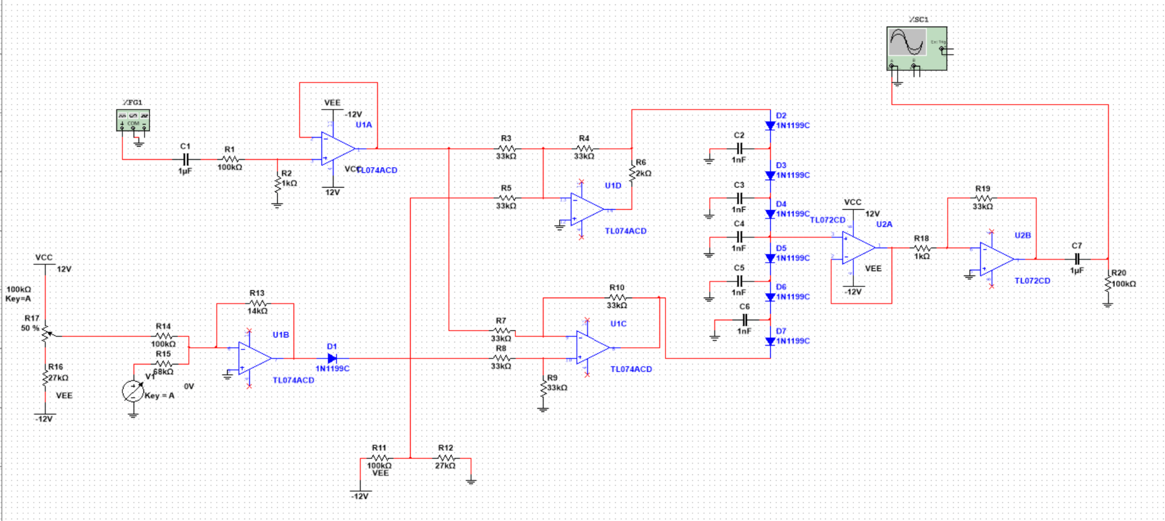

Picture 1: VCF (Voltage-Controlled Filter), Multisim Simulation
This circuit represents a voltage-controlled filter (VCF) designed to shape the frequency content of an input signal. The input signal is first AC-coupled and buffered using an operational amplifier to ensure proper signal conditioning and stable operation.
The core of the circuit consists of multiple RC (resistor-capacitor) stages combined with operational amplifiers (TL074 and TL072), which together form an active filter structure. The capacitors (C2–C6) and resistors define the cutoff frequency of the filter, determining which frequency components of the signal are attenuated or passed.
The diode network (D2–D7) introduces nonlinear behavior and plays a role in controlling the filter’s response, particularly affecting resonance and shaping characteristics. Control voltages applied to the circuit influence the operating point of the amplifiers and the effective resistance, allowing dynamic adjustment of the cutoff frequency.
The final stage amplifies and buffers the filtered signal, ensuring a stable output. Overall, the circuit demonstrates how a voltage-controlled filter can dynamically modify the spectral content of a signal, which is essential in analog sound synthesis and signal processing.

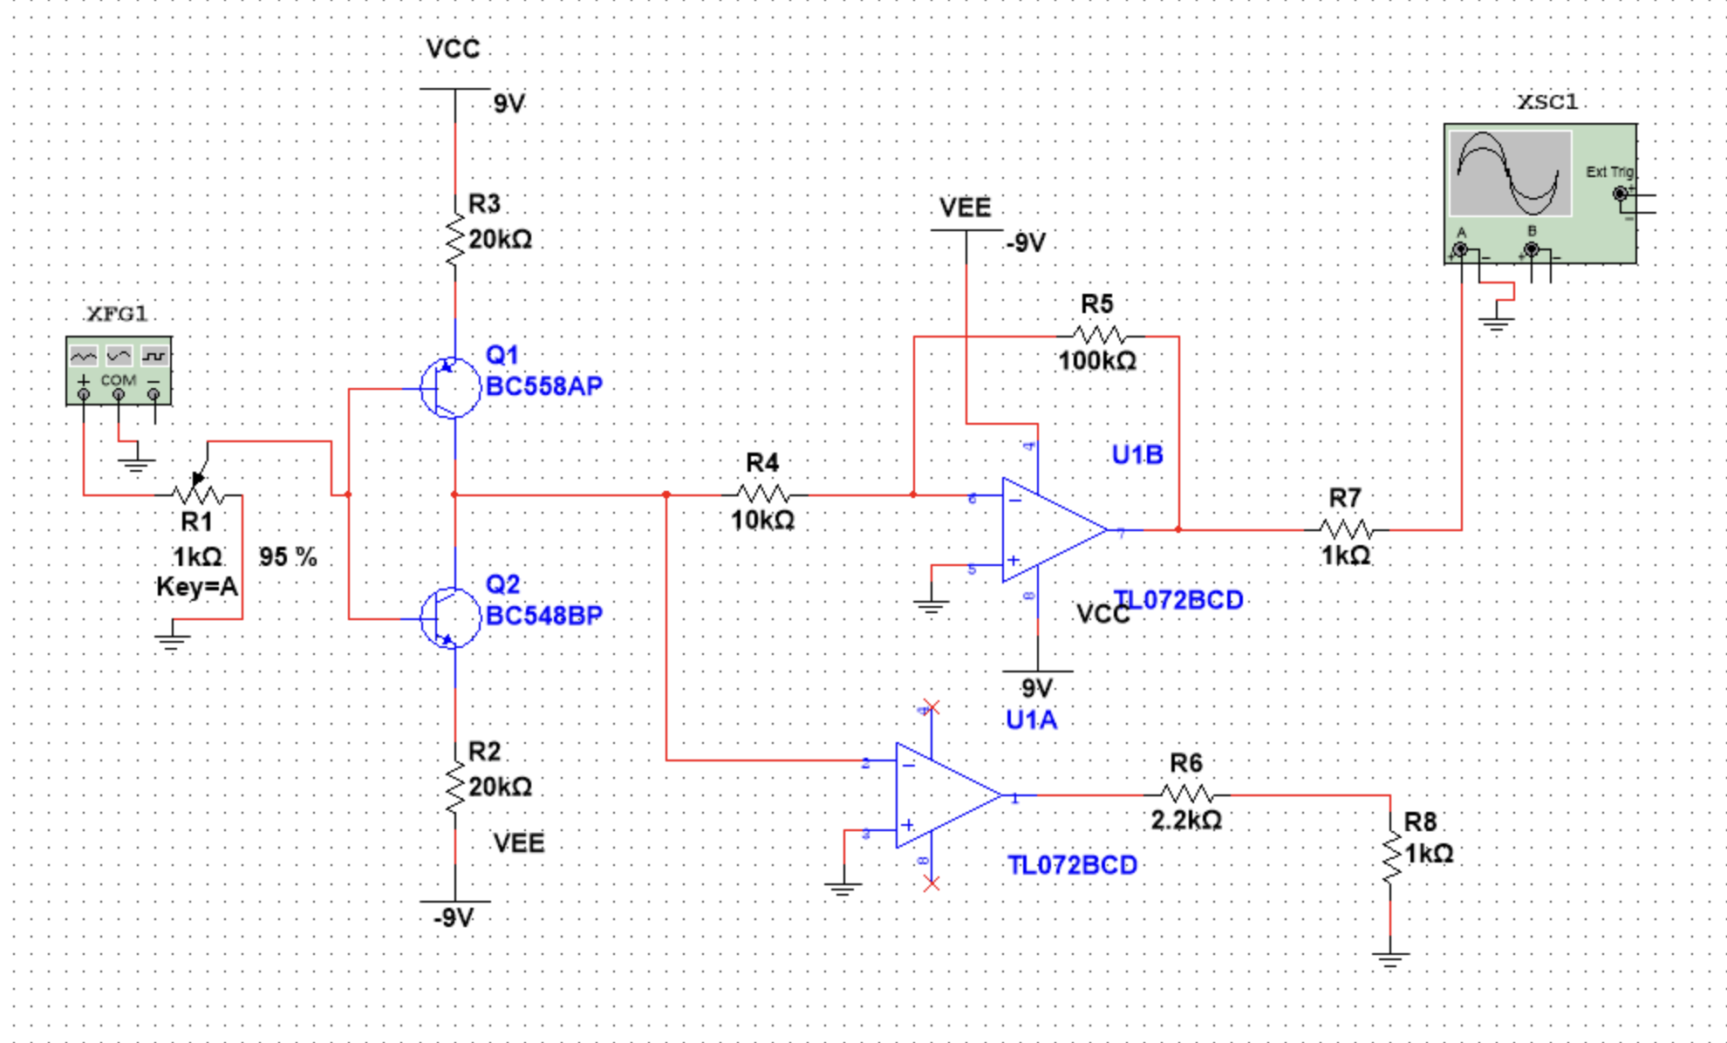
Picture 2: Wavefolder, Multisim Simulation
This circuit represents a wavefolder, a nonlinear signal-processing module used to increase harmonic complexity by “folding” the waveform when it exceeds certain thresholds. The input signal is first applied through a variable resistor (R1), which controls the input amplitude and therefore the amount of folding.
The core of the circuit is formed by a complementary transistor pair (Q1 and Q2), which introduces nonlinear behavior. These transistors act as a form of symmetrical limiter, bending the waveform once it reaches specific voltage levels. This creates additional peaks in the signal, effectively “folding” it back toward the center and generating new harmonics.
The processed signal is then passed through operational amplifier stages (TL072), which provide amplification and buffering. The feedback network (R4, R5) controls the gain and overall response of the circuit, while additional resistors shape the output level and stability.
Overall, the circuit demonstrates how nonlinear elements such as transistors, combined with amplification stages, can transform a simple input waveform into a more complex and harmonically rich signal. This principle is widely used in analog sound synthesis to create timbral variation and distortion effects.

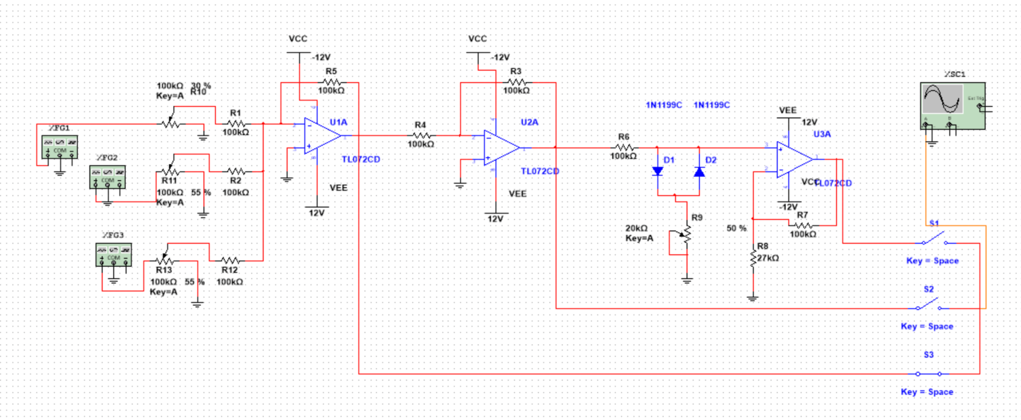

Picture 3: Mixer, Multisim Simulation
This circuit represents an analog mixer, designed to combine multiple input signals into a single output. Several input sources are applied through variable resistors, which control the amplitude (level) of each individual signal before mixing.
The first operational amplifier stage (U1A) acts as a summing amplifier, where the input signals are combined through resistors into a single node. This configuration allows multiple signals to be added together while maintaining control over their relative contributions. The following amplifier stage (U2A) provides additional gain and buffering, ensuring proper signal strength and isolation between stages.
A nonlinear section consisting of diodes (D1, D2) introduces optional signal shaping or soft clipping, which can affect the mixed signal by limiting its amplitude and adding harmonic content. This section can be adjusted using a variable resistor, allowing control over the intensity of the effect.
The final operational amplifier stage (U3A) serves as an output buffer and gain stage, delivering a stable output signal. Switches at the output allow selection or routing of the final signal path.
Overall, the circuit demonstrates how multiple input signals can be combined, adjusted, and processed within a single system, which is a fundamental principle in audio signal processing and modular synthesizer design.

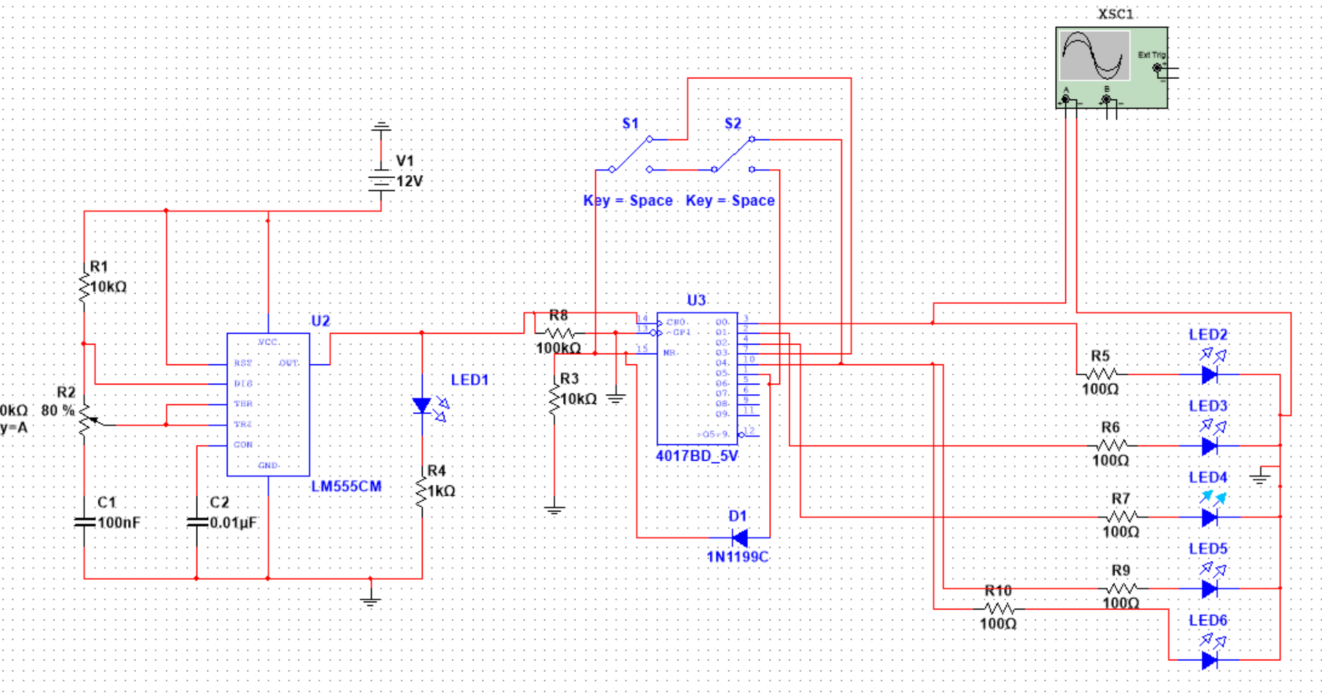
Picture 4: Sequencer, Multisim Simulation
This circuit represents a sequencer, which generates a sequence of stepped output signals used to control other modules in a system. The core of the circuit is based on a timer and a digital counter.
The LM555 timer (U2) operates as an astable oscillator, generating a periodic clock signal. The frequency of this clock is determined by the resistor-capacitor network (R1, R2, C1, C2), and it sets the speed of the sequence. This clock signal is then fed into the CD4017 decade counter (U3), which sequentially activates its output pins with each clock pulse.
Each output of the counter corresponds to a step in the sequence and is connected to LEDs, providing a visual indication of the active step. The switches (S1, S2) allow control over the sequence flow, such as resetting or modifying the progression.
Additional resistors and diodes help shape and control the signal levels, ensuring proper operation of the circuit. The output signals from the sequencer can be used as control voltages or triggers for other modules such as oscillators, filters, or amplifiers.
Overall, the circuit demonstrates how a clock source combined with a counter can generate a repeating sequence of signals, which is a fundamental concept in analog and modular synthesizer systems.

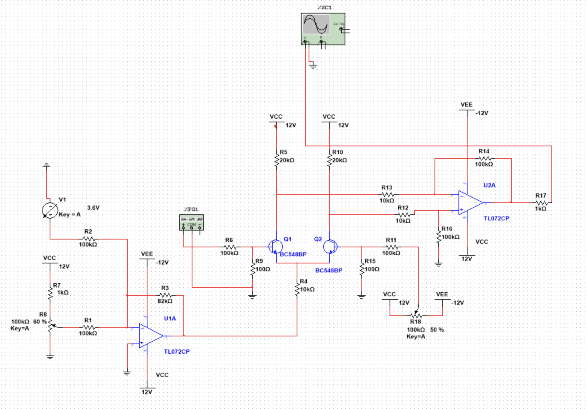
Picture 5: VCA(Voltage-Controlled Amplifier), Multisim Simulation
This circuit represents a voltage-controlled amplifier (VCA), which is used to control the amplitude of an input signal using a control voltage. The input signal is first applied to an operational amplifier stage (U1A), which conditions and buffers the signal for further processing.
The core of the VCA is formed by a pair of transistors (Q1 and Q2), which act as a variable gain element. Their operation is controlled by a control voltage applied to the circuit, which adjusts the current flowing through the transistors. As a result, the amplitude of the signal passing through this stage is modulated according to the control voltage.
Resistor networks around the transistors define the operating point and ensure stable and symmetrical behavior. The control voltage, adjusted through a potentiometer, determines how strongly the signal is amplified or attenuated.
The final operational amplifier stage (U2A) provides additional gain and buffering, delivering a stable output signal. This stage ensures that the output is suitable for driving other modules in the system.
Overall, the circuit demonstrates how a voltage-controlled amplifier can dynamically adjust signal amplitude, which is an essential function in analog synthesis for controlling volume, envelopes, and modulation effects.

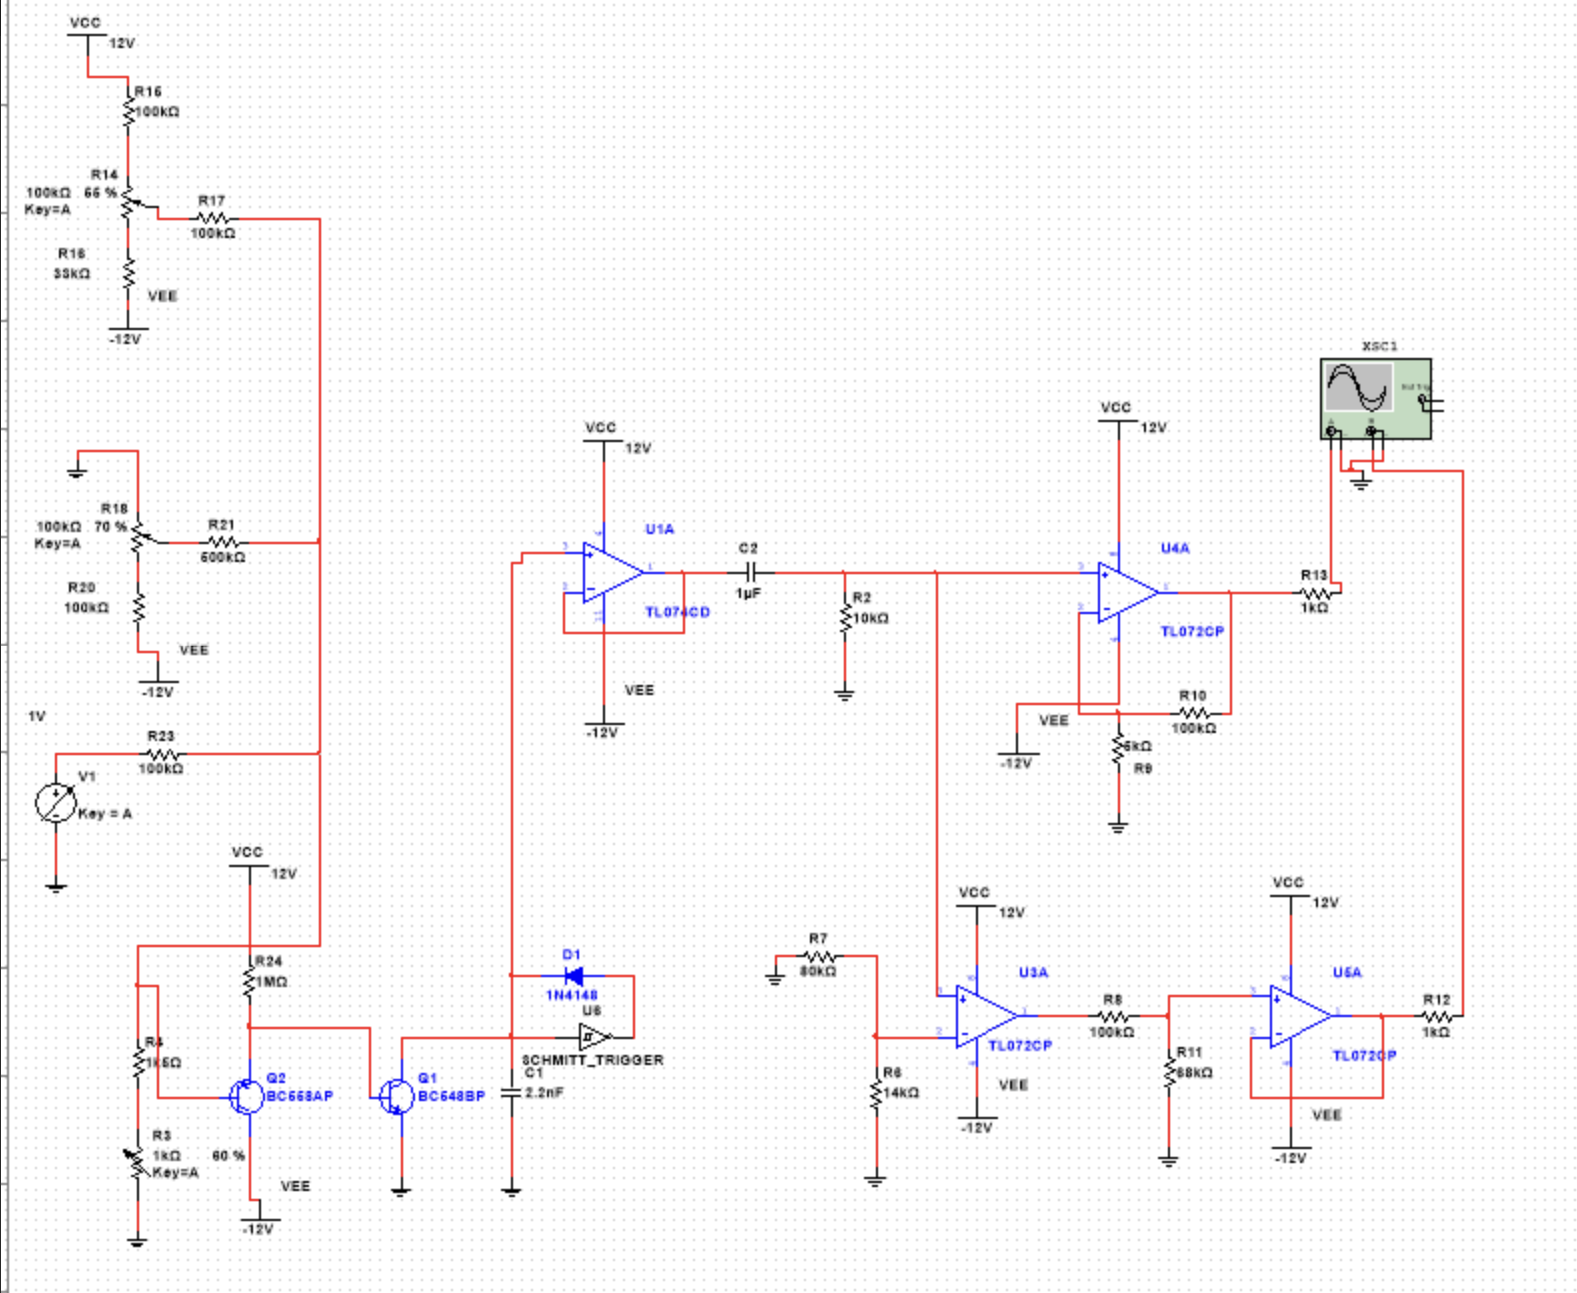
Picture 6: VCO(Voltage-Controlled Oscillator), Multisim Simulation
This circuit represents a voltage-controlled oscillator (VCO), which generates a periodic waveform whose frequency is controlled by an external voltage. The circuit is composed of several functional blocks that work together to produce and shape the oscillating signal.
The core oscillation mechanism is based on a Schmitt trigger and integrator structure. The Schmitt trigger (U8) generates a square wave by switching its output between two threshold levels. This output is fed into an integrator stage (formed by an operational amplifier and capacitor), which converts the square wave into a triangular waveform. The interaction between these two stages creates a continuous oscillation.
The frequency of oscillation is controlled by a voltage-controlled current source implemented using transistors (Q1, Q2). The control voltage adjusts the current flowing into the integrator capacitor, which directly affects the charging and discharging rate. As a result, increasing the control voltage increases the frequency of the output signal.
Additional operational amplifier stages buffer and condition the signal, ensuring stability and proper amplitude. Capacitors and resistors define timing characteristics and help stabilize the oscillation. The final stages provide output buffering and scaling, making the signal suitable for use in other modules.
Overall, the circuit demonstrates how a voltage-controlled oscillator generates and controls periodic signals, which are fundamental in analog synthesis for producing audio waveforms and modulation signals.
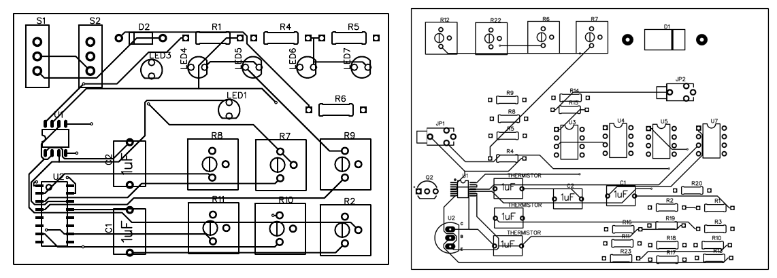
Picture 7: PCB Designs of Sequencer(Left) and VCO(Right), Easyeda
PCB designs of sequencer and VCO made in EasyEda (Std Project).The components on the both PCBs are through-hole ones(THT).

7. Distribution of Work Among Group Members
The project was carried out collaboratively, with responsibilities divided between the group members according to different functional modules and stages of development.
Anano was primarily responsible for the design and analysis of the Voltage-Controlled Oscillator (VCO), Wavefolder, and Voltage-Controlled Filter (VCF) modules. This included developing the circuit concepts, performing theoretical analysis, and conducting the majority of the simulations in Multisim to verify correct behavior and performance of these subsystems.
Andro focused mainly on the implementation of the Sequencer, Mixer, and Voltage-Controlled Amplifier (VCA) modules. In addition, Andro was responsible for creating the circuit schematics and carrying out the PCB-related design work using EasyEDA, ensuring proper integration of all modules into a coherent system.
Overall, the workload was distributed in a balanced manner, with both members contributing to the design, analysis, and validation of the system. The collaboration allowed the team to efficiently combine simulation, design, and implementation tasks, resulting in a fully functional voltage-controlled modular system.

8. Conclusion
In this project, a voltage-controlled modular system was designed, consisting of several functional blocks such as a voltage-controlled oscillator (VCO), voltage-controlled filter (VCF), voltage-controlled amplifier (VCA), mixer, wavefolder, and sequencer. The main objective was to explore how control voltages can be used to manipulate different characteristics of analog signals within a unified system.
Although the project was successfully developed at the conceptual and design level, the practical results were only partially achieved. While some modules demonstrated expected behavior during simulation, the complete system did not fully operate as intended. Certain parts of the circuit showed instability, unexpected responses, or failed to produce the desired output. These challenges emphasize the complexity of integrating multiple analog modules into a single system.
Despite these difficulties, the project was highly valuable from a practical and educational perspective. During the process, we gained hands-on experience in PCB design, soldering, and working with electronic components such as operational amplifiers (op-amps) and transistors. We also learned how to use essential laboratory equipment, including the oscilloscope, to analyze and debug signals. More generally, the project improved our ability to work in a laboratory environment, troubleshoot problems, and understand real-world circuit behavior beyond theoretical concepts.
The modular structure of the system remains an advantage, allowing individual parts to be improved independently. However, limitations such as sensitivity to component values, noise, and integration difficulties affected the final outcome.
For future work, it is recommended to focus on refining individual modules, improving stability, and conducting more thorough testing before full system integration. Simplifying the design and optimizing component choices would also help achieve better performance.
Overall, even though the final system did not fully meet all expectations, the project provided important practical skills and a deeper understanding of analog electronics and experimental work.

9. List of Used Literature
[1] P. Horowitz and W. Hill, The Art of Electronics, 3rd ed. Cambridge, U.K.: Cambridge University Press, 2015.
[2] M. Klein, “DIY Synthesizer Series (VCO, VCF, VCA, Mixer, Sequencer, Wavefolder),” YouTube, 2021–2024. [Online]. Available: https://www.youtube.com/@moritzklein/playlists
[3] https://www.craigstuntz.com/posts/2023-05-22-building-a-synthesizer-5.html

